|  |
| --- |
|  |
| Student Union Application  Team : UIX (User Interface & Experience) |
| |  |  |  | | --- | --- | --- | | MOHITKUMAR RANGHOLIYA OLUWATADE JOB ADEKOLA | 215410048  215383256 | [mranghol@deakin.edu.au](mailto:mranghol@deakin.edu.au)  [oadekola@deakin.edu.au](mailto:oadekola@deakin.edu.au) | |  |  |  | |
|  |

Table of Contents

Introduction 2

Features 2

Members Registration 2

Events 2

News and Update 3

Discount and offers 3

Settings 3

Contact Us 3

Reliability 4

Device compatibility 4

Browser compatibility 5

Scalability, Privacy and Security 7

HP LoadRunner………………………………………………………………………………………………………………………………….7

Testing 9

Test cases 9

Test Summary 10

User Manual 12

Deployment Steps 17

References 18

# Introduction

Cloud computing has been at the heights of its implementation over the past few years. Services are now powered on the cloud like never before. Clients only need to subscribe to these services and have full access to their usage as it’d be when run in-house. PaaS is one of the services running on the cloud for application developers to have easy access to. It provides huge benefits in terms of security, reliability, robustness, privacy and transparency.

The web based application proposed in this industrial project implemented and hosted on Microsoft Azure (PaaS Provider). This allowed for a full feature that come with Azure to be fully implemented on the web based application.

The report will give a round-up overview of how the application was developed, all the features it contains and a user manual guide for students to use the web application. It also contains some of the unique services supplied by Azure to make the application a much more secured and scalable cloud based application.

# Features

The student union application is a web application powered by Microsoft Azure. It’s a web based application that comprises of the following features in order to run a university student union society. These features allow for automated management of several updates, news and offers within the student union community.

## Members Registration

The members registration page contains details about student’s personal profile which are eventually used to set up student’s profile after joining the student union. This registration page is developed in a way that it allows for a **JSON** enabled editing after registering. After the registration is done, the user can now login to access all features of the student union application.

## Events

The events feature contains information about upcoming, present and past events within the student union community. The events page is designed in such a way that allows for an interactive interface. The JavaScript enabled page comprises of a calendar of the present month. Each date contained in the calendar has embedded links for different events for that day. On mouse hover, the events are displayed through JavaScript pop up.

## News and Update

**The** news and update feature contains all about what’s going on in the university, the latest trends, entertainment news and other updates that’d be of huge interest to university students. In the news and update page, all major news are shown with a thumbnail picture representing news image. On click of the thumbnail, user is redirected to another page containing a full information about the news.

## Discount and offers

The discount and offer feature contains information about all discounts that are provided by the union. These discounts range from shopping to entertainments and events. In the discount and offer page, an image representing the provider of the discount and then the date the offer was uploaded as well as the location of the company. On click of **“read more”**, more details about the offer and discount is displayed.

## Settings

The settings feature allows individual users to manage their profile and details in the student union application. It allows for editing, updating and deleting profile contents. In the settings page, all profile information of the user can be changed and then updated on the database.

## Contact Us

The contact us feature is an enquiry form where students can submit their queries and get reverts from the student union management.

# Reliability

## Device compatibility

The student union app was designed to be responsive on different devices. Through the implementation of twitter bootstrap, the student union app is able to fit in perfectly into different platforms and still maintains its quality and features. The figure below shows how the app is displayed on different devices:

**Online testing link :** [**http://mobt.me/SfNl**](http://mobt.me/SfNl)

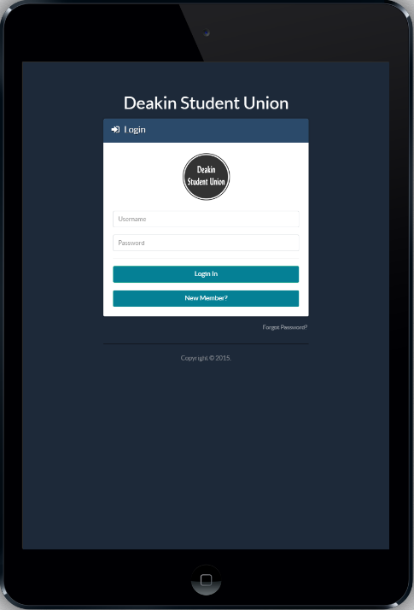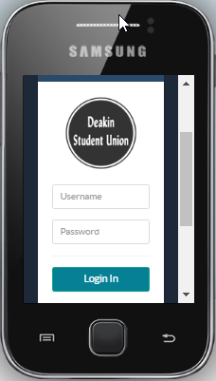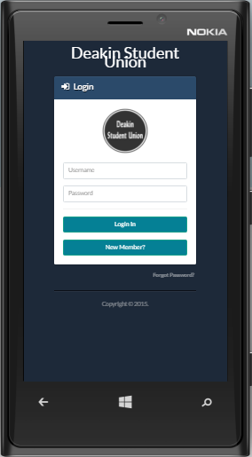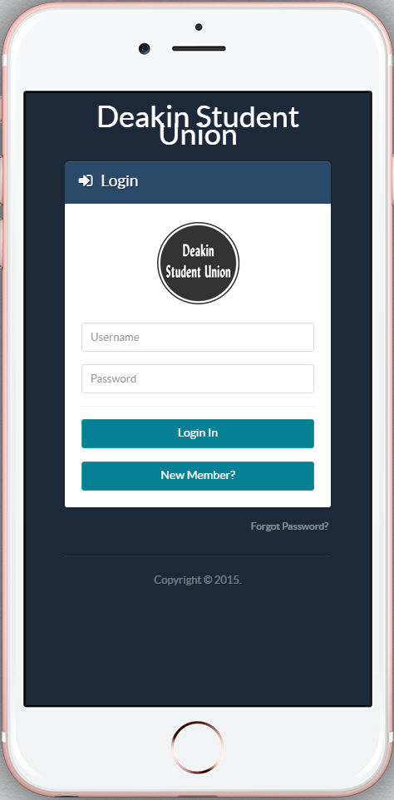

## Browser compatibility

The application is compatible with several browsers such as Firefox, Chrome, Internet Explorer, Safari and much more. With the use of browser testing tools online, all browser compatibility bugs have been fixed and it runs smoothly. The figure below shows how the app is displayed on different browsers:

**Cross browser compatibility check :** [**https://www.browserstack.com/screenshots/a3bb82c9b7172e1c133e5ad445e80b5e94442fdc**](https://www.browserstack.com/screenshots/a3bb82c9b7172e1c133e5ad445e80b5e94442fdc)

**Browser : Google Chrome**

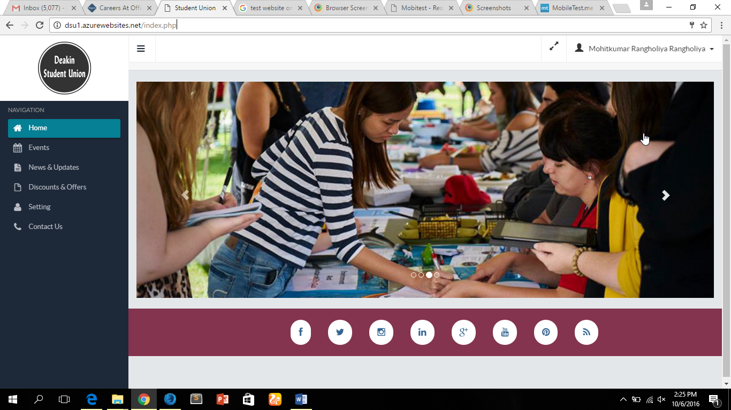

**Browser : Mozilla Firefox Developer Edition**

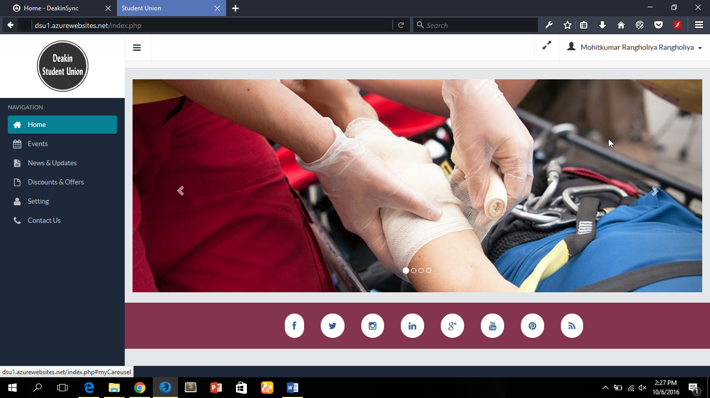

**Browser : UC Browser**

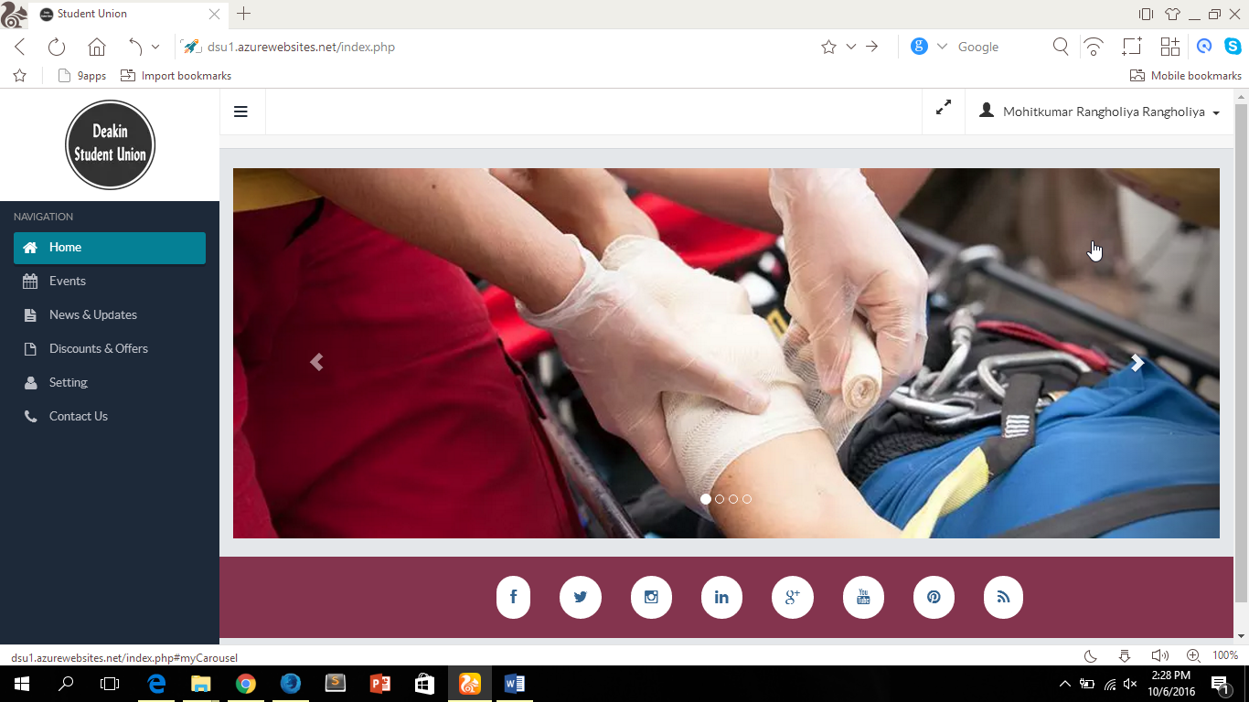

# Scalability, Privacy and Security

The scalability attribute of Microsoft Azure allows the student union application to run smoothly even on high traffics. A resource called **exponential back-off** allows for quick retries when the server returns an error code as a result of high traffic. The exponential back-off allows the load on the storage to decrease automatically. Thus, allowing the web application to run smoothly with minimal error latency.

The privacy policy adopted by Microsoft has enabled subscribers to Azure platform to be sure of complete protection and safety of their customers’ data. All data stored into Azure database from the student union app is solely monitored by the admin thus allow higher degree of privacy in the data store in Azure.

The security feature implemented by Microsoft on Azure are up to date security techniques that ensures that data is secured. This includes using industry standard transport protocols for data in transit and AES-256 encryption for data at rest. The advanced encryption standard allows all vital details about students stored in the database are encrypted during storage.

## HP LoadRunner

The introduction of HP LoadRunner Performance testing tool was based on its relative scalability testing feature it provides. So, based on this, it was used to test and investigate the scalability rate for Microsoft Azure based application.

HP LoadRunner is a performance testing tool that determines how a system performs in regards to responsiveness and stability under a certain workload. Its purpose is to investigate, measure, validate, and or verify attributes of the system, such as scalability, reliability and resource usage. The screenshots below show the outputs of the performance test performed on the student union application when hosted on Microsoft Azure. The screenshot shows a certain number of virtual users, the throughput and the total number of transactions performed.

* The screenshot shows when the HP LoadRunner is tested with 3000 virtual users under a real-world scenario on the student union application.

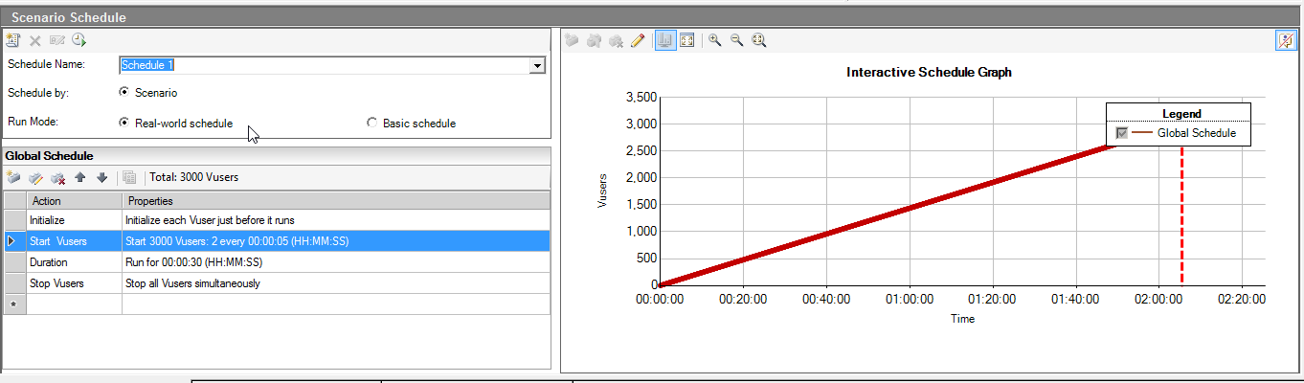

* The screenshot below shows the throughput as a result of the input provided in the above. The graph shows the throughput (i.e. the amount of load the web application under test can take at any given time) of the web application.

From the graph, we can deduce that the web app can take a traffic worth 1MB of load in 5 seconds. This capacity continuously increases as the load increases as well and only plummeting at 45secs where there was server failure.

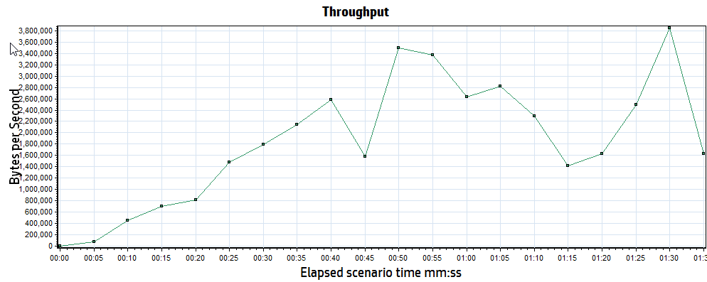

* The screenshot below shows number of transactions (actions) carried out by the virtual users. The chart shows the total number of successful transactions, number of stops and gives an overview of the summary of the test performed.

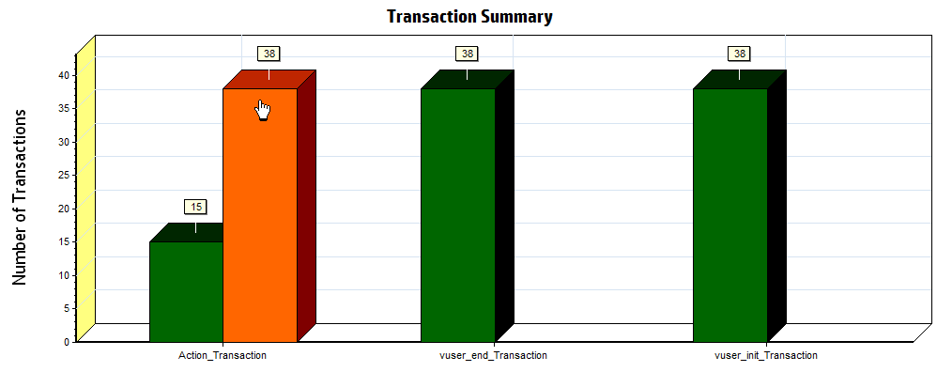

* The screenshot below shows the graph representing the number of virtual user, the time taken to complete transactions before increasing the load.

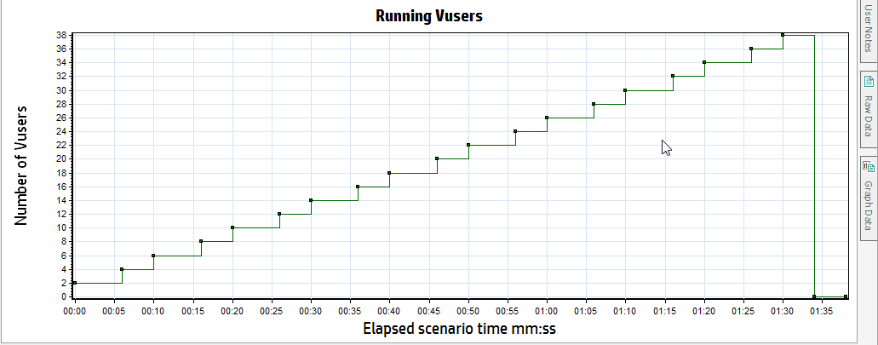

# Testing

This reflects every aspect of the testing phase during and after the implementation phase of the application development. The testing technique that was used is **regression testing.** This allowed for a progressive testing all through the software development lifecycle. The screenshots below show some of the test cases written and the final test summary.

## Test cases

The excel sheet screenshots below represents the test cases written for different modules of the web application. The screenshot shows the project name, test description, module name, test scenario etc.

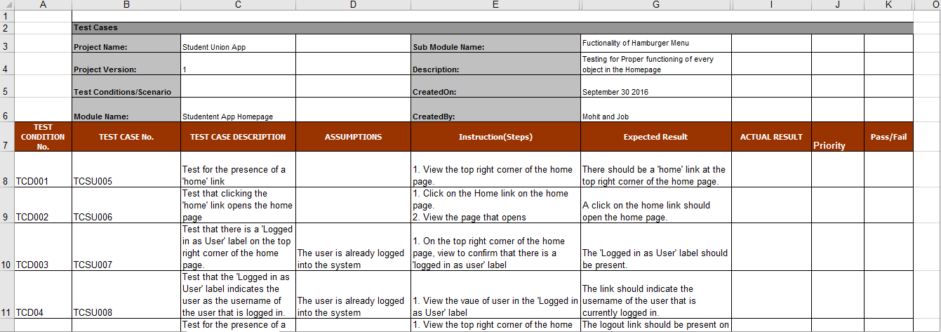

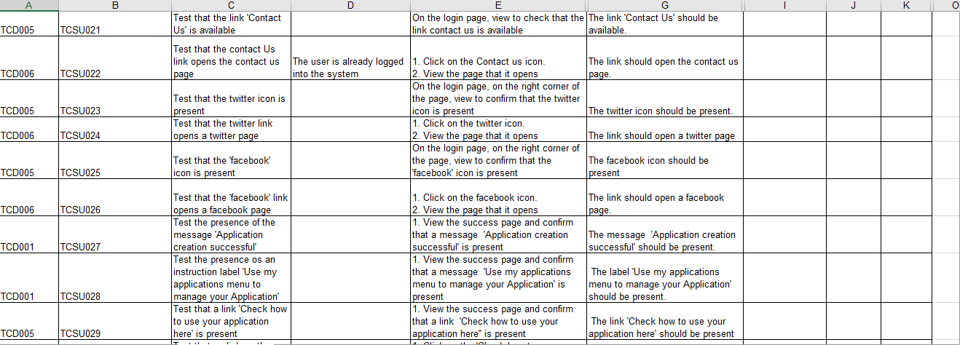

## Test Summary

The test summary gives an overview of the execution and defect summary in the form of a bar chart. The bar chart shows the number of passes, fails as well as new defects, rejected defects and fixed defects. The is done until no bugs is found as seen below.

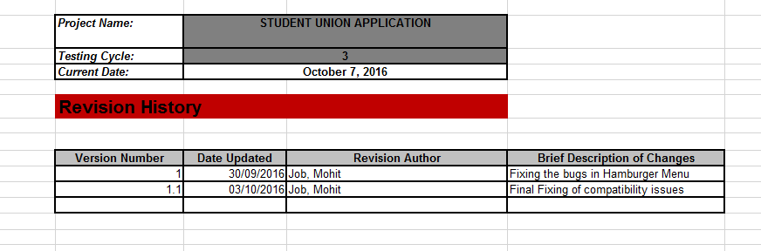

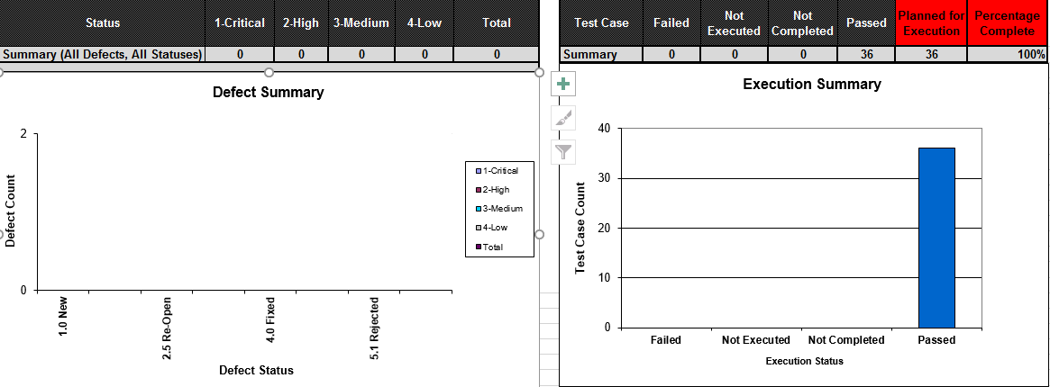

The test execution summary shows that after all test cases were executed, no bug was found and all test cases were executed successfully.

# User Manual

**Step-1 : Login**

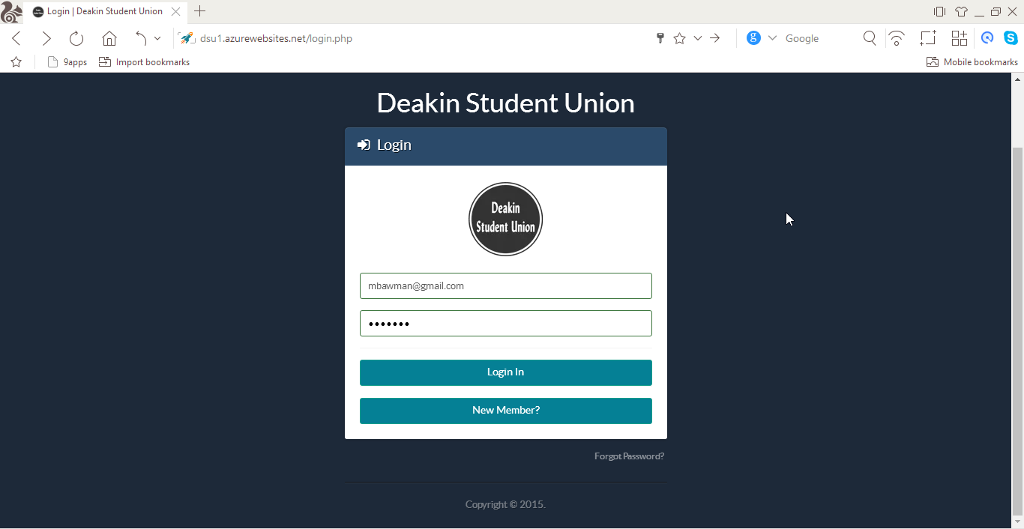

**Step-2 : Registration**

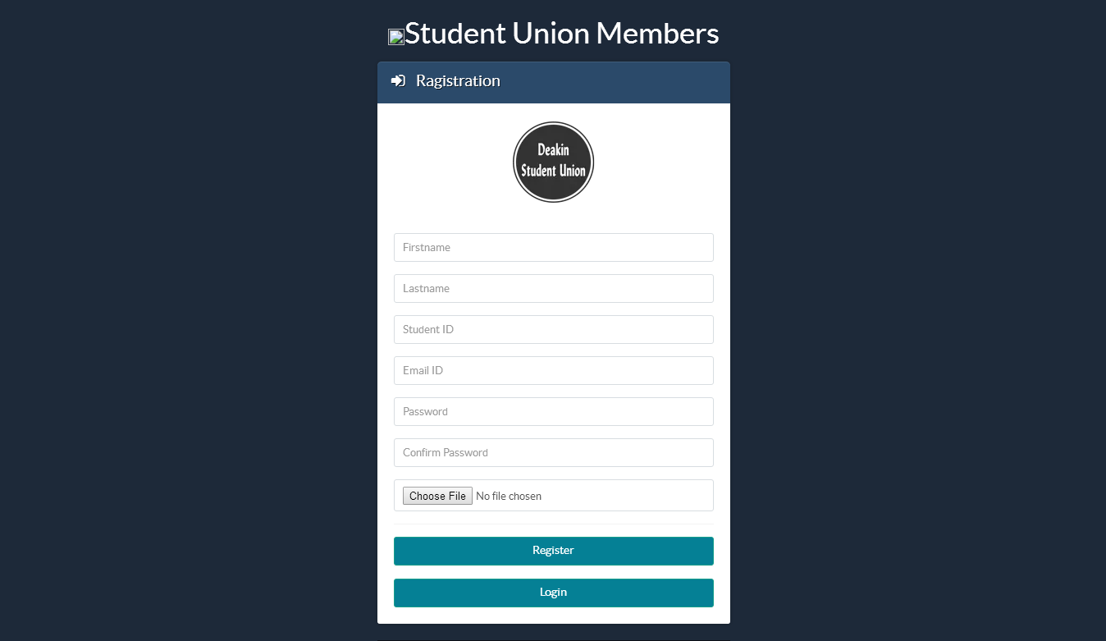

**Step-3 : Home Screen**

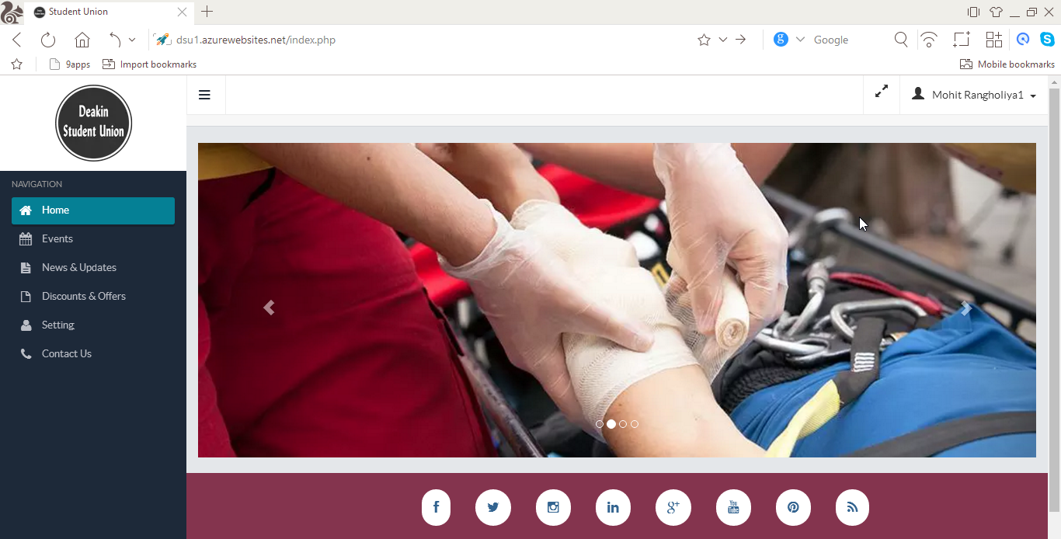

**Step-4 : Events**

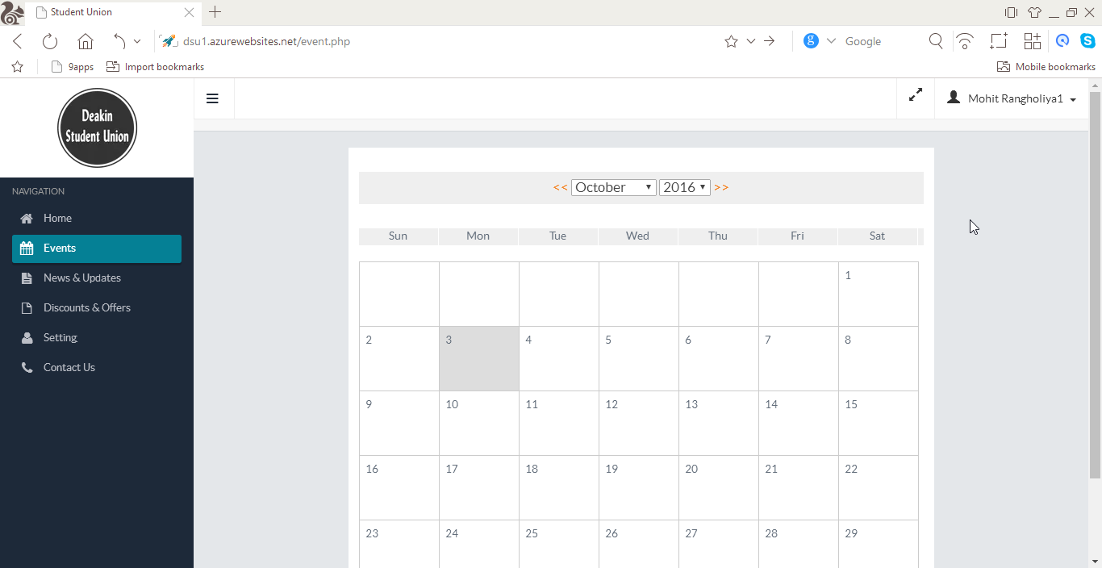

**Step-5 : News & updates**

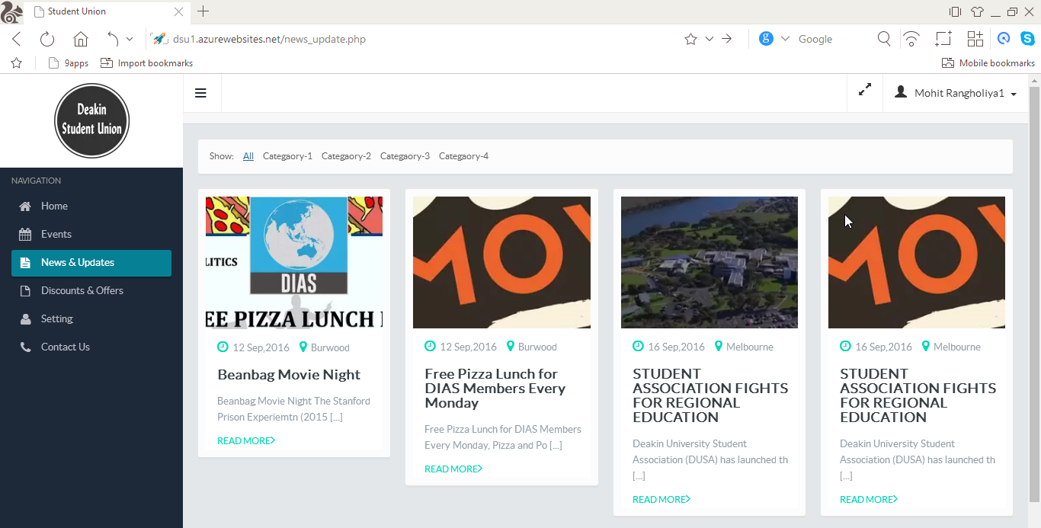

**Step-6 : Read particular news**

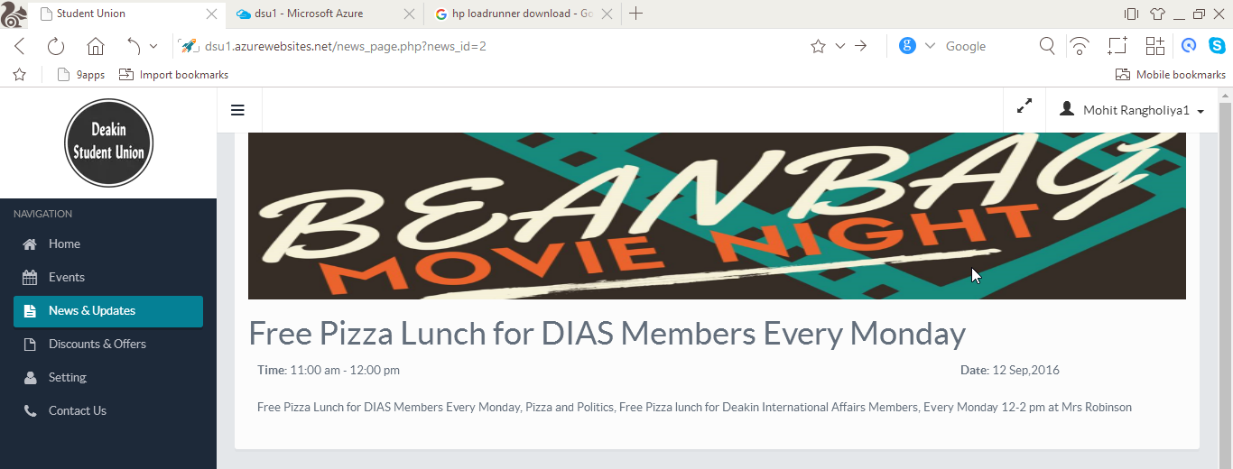

**Step-6: Discount & Offers**

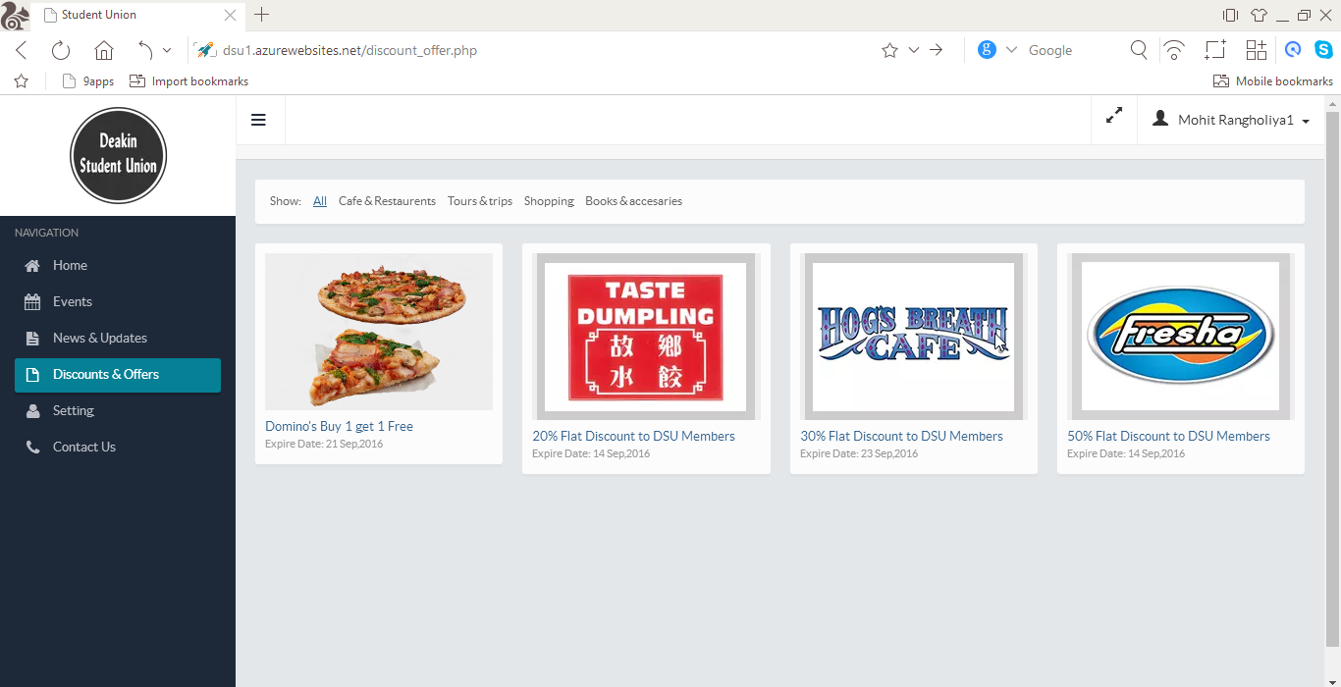

**Step-7 : Click on particular offer**

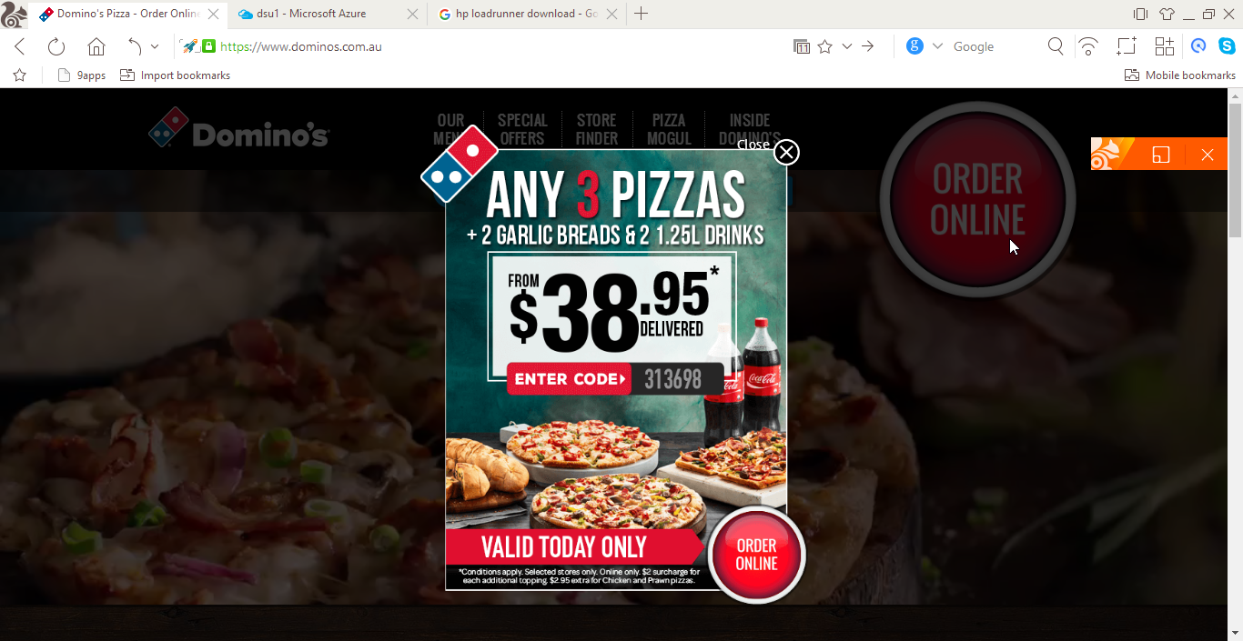

**Step-7 : Settings**

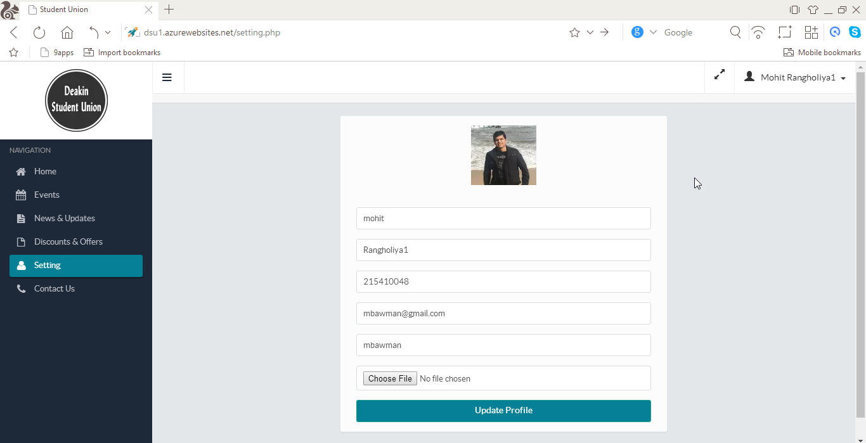

**Step-8 : Contact Us**

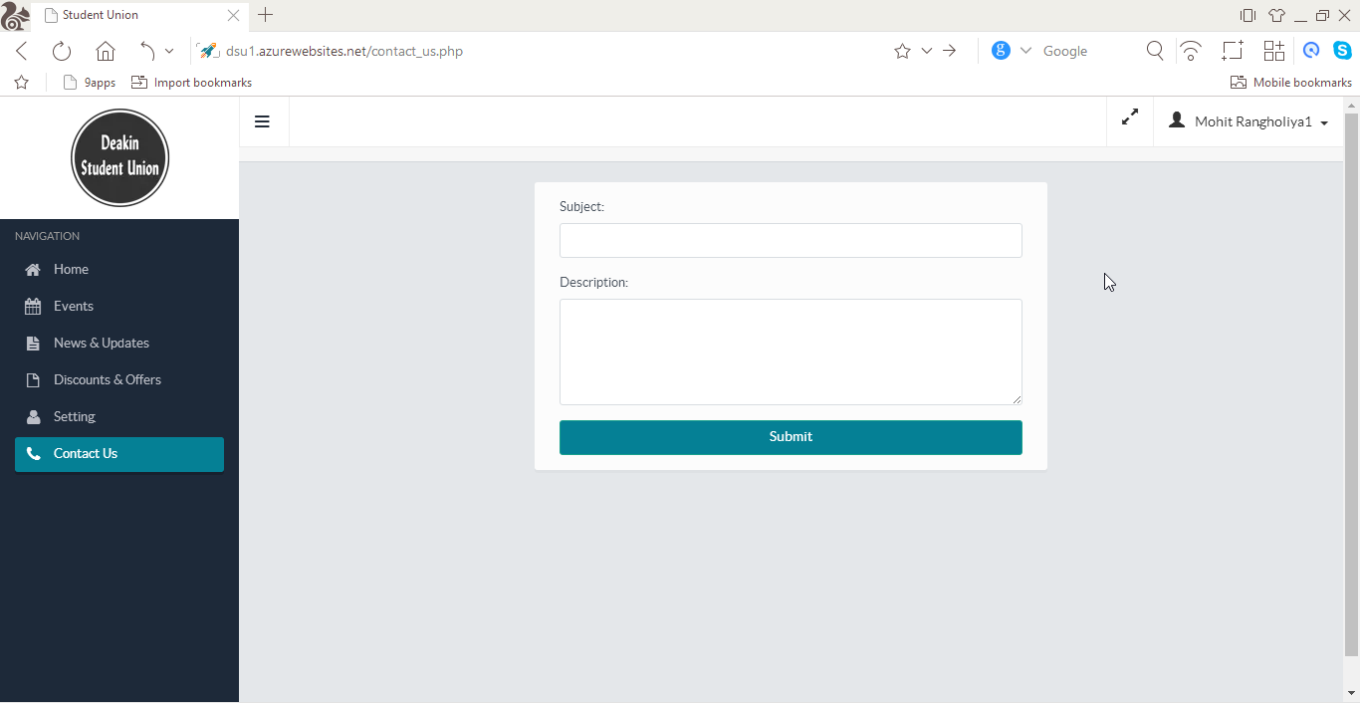

# Deployment Steps

**Step-1 : Azure Login**

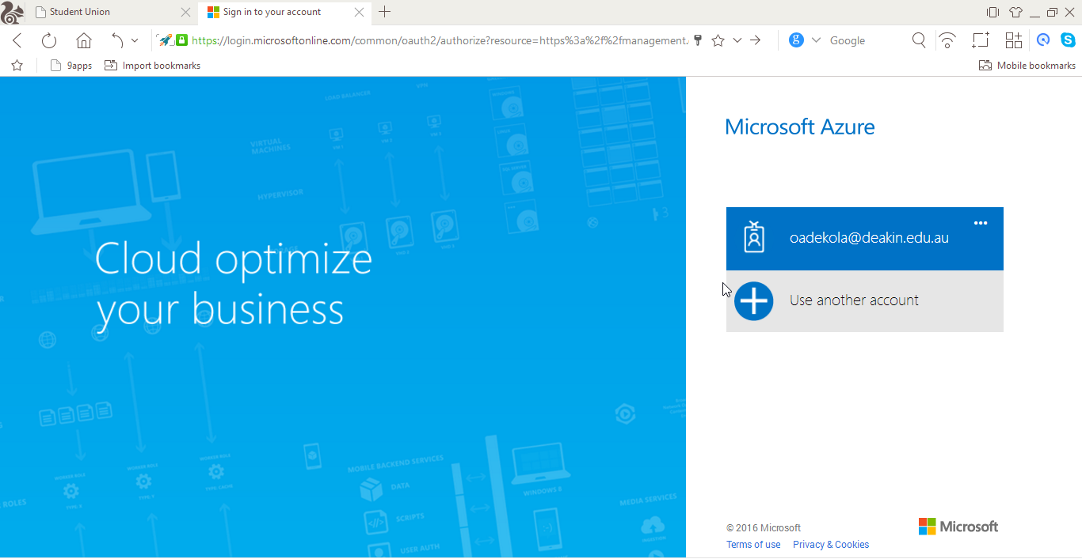

**Step-2 : Azure Dashboard**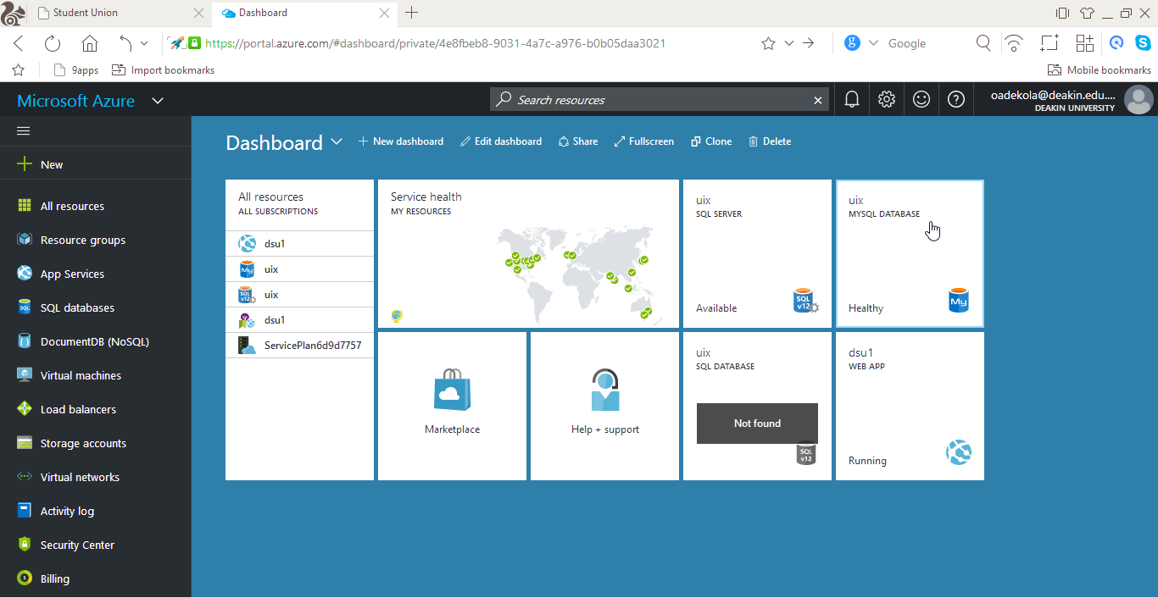

# References

1. Azure.microsoft.com. (2016). *Microsoft Azure Trust Center | Azure*. [online] Available at: https://azure.microsoft.com/en-us/support/trust-center/ [Accessed 4 Oct. 2016].
2. Browserstack.com. (2016). *Cross Browser Testing Tool. 1000+ Browsers, Mobile, Real IE.*. [online] Available at: https://www.browserstack.com [Accessed 6 Oct. 2016].
3. Mobiletest.me. (2016). *MobileTest.me - Test your mobile sites and responsive web designs*. [online] Available at: http://mobiletest.me/ [Accessed 6 Oct. 2016].